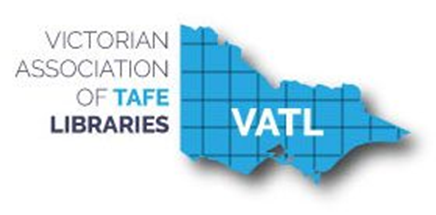

VATL Annual Report 2018

Table of Contents
EXECUTIVE REPORTS 3
President’s Report 3
VATL Executive Members 2018 5
Treasurer’s Report 6
2016 VATL Finances 7
SUBSIDIARY GROUP REPORTS 10
Cataloguing Acquisitions Serials and Systems (CASS) 10
Liaison, Information & Training (LIT) 11
Vocational Libraries Advisory Committee (VLAC) 12
MEMBER LIBRARY REPORTS 14
Bendigo Kangan Institute 13
Box Hill Institute 14
Chisholm Institute 15
TAFE Gippsland [formally Federation Training] 16
Federation University 17
The Gordon 18
Goulburn Ovens Institute of TAFE (GOTAFE) 19
Holmesglen Institute 21
Melbourne Polytechnic 22
RMIT University 23
South West Institute of TAFE 24
Sunraysia Institute of TAFE (SuniTAFE) 25
Swinburne University of Technology 26
Victoria University 27
William Angliss Institute 28
Wodonga TAFE 29

EXECUTIVE REPORTS

President’s Report
Colin Sutherland

In 2018 the Committee set its sights high on what we would like to achieve the year. It was quite an enthusiastic list if I say so myself. I am very proud and pleased to say that we ticked off all the projects. They included:

- Website & Rebranding
- With the support via a generous grant from VDC [VET Development Centre] in late 2017 we:
- Commissioned a website designer/developer
- Designed a new VATL Logo
- Selected a new website platform [WordPress] that allows for easy content management and has a modern look and feel
- Migrate existing website content over to the new platform
- Review the content and add a Calendar of Events
- Collect banner images from all member libraries to showcase the site
- Provide WordPress training for all Committee members on managing site content
PD Workshops, Webinars & Tours
- 1 CASS Special Libraries Tour
- 2 LIT Workshops
VATL Constitution
- Reviewed the existing constitution to check its relevance and accuracy
- Reviewed the Consumer Affair Victoria – Incorporated Associations Model Rules and identified additional content/changes from these to incorporate into our constitution
- Consolidated all suggested changes into a proposed new version of the constitution
- The committee ratified a final draft and circulated it to members prior to the AGM
VLAC [VET Libraries Advisory Board]
Congratulations to Brenda Burr [Wodonga TAFE] as Victorian VLAC representative with ALIA for taking on the role as Chairperson in April.

Thank you:

To the outgoing committee and sub-committee members for your valued input and professional contribution to VATL over the years.

CASS Committee - Krystyna Derwinska [RMIT University]
CASS Committee Convenor – Lynette Stanyer [Kangan Institute]

To all the member libraries that have hosted meetings, workshops and webinars this year thank you for your support and contribution to the success of VATL.
Good Bye

In 2005 I joined VATL TAG [TAFE Acquisitions Group] with Kathleen Dauska [NMIT] to help convene and revive a struggling sub-group. I am happy to say we did it! VATL has gone from strength to strength thanks to many enthusiastic and committed members. Over the years I have witnessed a number of amazing VATL events including; interstate PD tours with guest speakers to; Canberra in 2007, Sydney in 2012, Hobart in 2015 with numerous trips to regional Victorian libraries.

The highlight to me was the first TAFE Australian Library Conference [TALC] in 2011 which we hosted over 2 days at William Angliss Institute. It was a huge success with around 300 delegates attending, complete with trade show and corporate sponsorship. I am very proud to have been involved with such a professional organising committee (even though some said it could not be done! No names mentioned).

My role at Chisholm Institute has now moved from a Team Leader in the Library to a Team Leader in Records & Information Management reporting to the IT Services Manager, this allows for lots of new challengers and new TAFE records user groups to be involved. I do look forward to these new challenges.

This has been my final year working in the library field. I sincerely thank all of you for your friendship and support and wish the new VATL Committee and members all the very best and I hope VATL’s spirit of collaboration and knowledge sharing continues for year to come.

VATL Executive Members 2018

President Colin Sutherland
Chisholm Institute

Secretary Leanne Meere
Swinburne University of Technology

Treasurer Jill Perkins
Box Hill Institute

CASS Convenor Lynette Stayner
Melbourne Polytechnic

LIT Convenor Naomi Ferguson
Holmesglen Institute

VLAC Representative Brenda Burr
Wodonga TAFE

Treasurer’s Report
Jill Perkins

VATL had an opening balance at 1 July, 2017 of $8,802.60 and a closing balance of $12,051.95 at 30 June, 2018.

Total expenditure during the year was $4,200.65. The main expense was $2000 to redevelop the VATL website. Other expenditure items included: $1, 068 of workshop and meeting expenses (primarily catering for professional development activities arranged by the special interest groups CASS and LIT); $838.20 in website expenses; and smaller amounts in banking costs and incorporation fees.

Total income for the year was $7,450. The primary component of this was $5,300 in membership fees. Additional income was provided by the VET Development Centre towards redevelopment of the VATL website ($1,500) and website hosting charges ($400). Elsevier also provided $250 towards lunch costs at the CASS event in April.

No changes to annual membership fees are anticipated for 2019.
Further financial details are provided in the following VATL Annual Summary.

Note: The Treasurer’s role was initially held by Sharon Stewart, with Jill Perkins taking the role over in late October, 2017.

2017/2018 VATL Finances
Financial year ending 30 June 2018
Opening balance: 1/7/2018 | $8,802.60
July Income |  | July Expenditure
 |  | CBA Merchant Fee | $15.70
 |  | CommBiz Fee | $6.05
August Income |  | August Expenditure
 |  | CBA Merchant Fee | $11.00
 |  | CommBiz Fee | $5.50
 |  | Uber web hosting charges (2 years from 26/07/17 | $598.80
September Income |  | September Expenditure
 |  | CBA Merchant Fee | $11.00
 |  | CommBiz Fee | $5.78
 |  | Uber web hosting charges | $179.40
October Income |  | October Expenditure
 |  | CBA Merchant Fee | $39.00
 |  | CommBiz Fee | $5.78
November Income |  | November Expenditure
VDC funding of web hosting charges ($200 p.a. for 2 years) | $400.00 | CBA Merchant Fee | $11.00
 |  | CommBiz Fee | $5.50
December Income
VDC funding for website redesign | $1,500.00 | CBA Merchant Fee | $11.00
 |  | CommBiz Fee | $5.50
2018
January Income |  | January Expenditure
 |  | CBA Merchant Fee | $11.00
 |  | CommBiz Fee | $5.50
 |  | Catering for AGM, Cheque: 000461 | $230.80
February Income |  | February Expenditure
Membership payments | $1,300.00 | CBA Merchant Fee | $11.00
 |  | CommBiz Fee | $5.50
 |  | Consumer Affairs Annual Fee, Cheque: 000460 | $56.90
March Income |  | March Expenditure
Membership payments | $2,700.00 | CBA Merchant Fee | $11.60
 |  | CommBiz Fee | $5.50
 |  | Catering for October executive meeting, Cheque: 000462 | $176.90
April Income |  | April Expenditure
Membership payments | $900.00 | CBA Merchant Fee | $26.92
Elsevier funding for CASS Lunch | $250.00 | CommBiz Fee | $5.50
May Income |  | May Expenditure
Membership payments | $400.00 | CBA Merchant Fee | $11.22
 |  | Website redevelopment, Cheque 000466 | $2,000.00
 |  | CASS day 20th April, Cheque 000464 & 000465 | $609.90
June Income |  | June Expenditure
 |  | CBA Merchant Fee | $11.00
 |  | CASS day 20th April, Cheque 000463 | $50.40
 |  | VATL.com.au domain name renewal TPP, Cheque 000467 | $60.00
Total income | $7,450.00
ANNUAL STATEMENT SUMMARY
Income |  | Expenditure
Memberships | $5,300.00 | Bank Fees/Charges | $237.55
VDC funding of website redesign | $1,500.00 | Workshop/Meeting Expenditure | $1068.00
VDC funding of website hosting | $400.00 | Incorporation Fees | $56.90
Elsevier Lunch Sponsorship | $250.00 | Website Expenses | $838.20
 |  | Website Development | $2,000.00
Total | $7,450.00 | Total | $4,200.65
Closing account balance at 30/06/18 | $12,051.95

Actual closing balance at 30/06/18 $12,051.95 from bank statements
Difference $0.00

SUBSIDIARY GROUP REPORTS

Cataloguing Acquisitions Serials and Systems (CASS)

Lynette Stanyer

Lynette Stanyer (Convener)
Krystyna Derwinska
Kathleen Dauksza
Ruth Downs
Colin Sutherland

Lynette Stanyer has resigned as the Committee Representative. The committee is activity searching for a new representative preferably from Victoria University, “but anyone, to boost the brains trust and get fresh ideas”
The CASS group started the year by meeting up on Friday 02nd February 2018. It was decided that CASS would organize three events for 2018.
Workshop 1
Friday 20th April 2018 10.00am – 3.00pm at Richmond Campus Bendigo Kangan Institute
The workshop was held at Bendigo Kangan Institute on Friday 20 April 2018. The program for the day consisted of the following elements:
Moodle, Copyright, embedding and linking resources. John Collins from EWorks will be the guest speaker
Workshop 2
Tuesday 24th July 2018 9.30am – Noon Webinar
Regional Institutes present on their experiences, highlights and lowlights – this year we have a series of questions we would like the Institutes to address their presentation and talk to the following subjects:
- Student engagement
- Spaces
- Typical day at their Institute
- Subject Guide/Lib guides
- Statistics
Workshop 3
Friday 16th November 2018 - Library Tour to Geelong

- Libraries visited:
- Deakin University, Geelong Campus
- Geelong Public – The Dome
- Marcus Oldham College
- Gordon TAFE, East Geelong Campus
The group travelled to Geelong via bus. On the way back to Melbourne there was an accident on the West Gate Bridge which meant there was a 2 hour delay due to traffic congestion. The bus driver dropped everybody at a railway station which meant that the group was able to get back to Melbourne on time. Some of our regional friends had to get country trains so it was really important that we were not delayed.

Liaison, Information & Training (LIT)
Naomi Ferguson
This year the LIT Committee held two workshops. After a hiatus of LIT events in 2017 the committee’s aim for the year was to promote conversations to reconnect, to enable the sharing of knowledge and promote the work we are doing.
Workshop 1
Theme: Sharing skills, knowledge and experiences
We started the day with an extended whip around to hear what the institutes had been up to.
Presentations on Librarians as researchers, and the purpose and setting up of institutional repositories.
Attendees: 23 Librarians from 11 institutes.
Thank you to our guest speakers: Dr Fiona Wahr (Melbourne Polytechnic), Em Johnson (Swinburne Research Bank) and Joey Chung (Holmesglen).
Thank you also to Maggie Iovannella and Kathleen Dauksza for helping to organise the event at Melbourne Polytechnic
Workshop 2
Theme: Imagine. Initiate. Implement: Being Active Liaison Librarians in the 21st Century
We had a tour of Holmesglen’s campus on St Kilda Road, with thanks to the Librarians who work at City Learning Commons.
Presentations and sharing/brainstorming session on marketing, and planning and conducting information literacy sessions.
Attendees: 26 Librarians from 12 institutes.
Thank you to our guest speakers: Clare Duffy (Federation University) and Margherita Meeking (Holmesglen)
As the committee was reformed this year, most of us were new. It’s been a year of learning and we have worked hard to put on workshops that are diverse and interesting for new and seasoned Librarians. It has also been a great reminder of how supportive Librarians are as many have actively assisted us throughout the year.
Thank you to the LIT committee: Marian Chivers (Federation University), Margherita Meeking (Holmesglen) and Jay Yurdakul (Holmesglen). It was a pleasure to work with an enthusiastic and motivated group.

Brenda Burr

Vocational Libraries Advisory Committee
(previously TAFE Library Advisory Committee)
VET Libraries Advisory Committee (VLAC) report to VATL AGM Friday 23rd November, 2018
This is my third year as VLAC representative on the VATL Executive. There have been a number of changes to membership of the VLAC committee during the year. Debra Hannan (Tas), Ruth Barnett (WA) and Beatriz Aroche (NSW) resigned and we were then joined by Jane Bollard (Tas), Jo Clark (NSW), and a new representative from WA is expected to join the next meeting in December. Other representatives include Angela Orth (Qld), Jaci Ganendran (ACT) and Helen Ebsworth (ALIA director as liaison with VLAC). In April I became the new Chairperson of VLAC after Debra Hannan stepped down.
VLAC achievements 2018
- VET Specialisation of ALIA PD scheme launched 13th December, 2017. Registrations have been low, but downloads of the competencies and skills audit checklists have been encouraging. Personal members of ALIA are encouraged to consider participating in the PD Scheme. Any TAFE staff may find the competencies and skills audit checklists useful in planning their professional development

- TAFE Directory and National Reciprocal Borrowing Scheme participants updated on the ALIA website Updated Terms of Reference for the committee. The main project this year has been reviewing and revising the VET libraries survey. Last run in 2016, VLAC undertook to repeat this survey every three years. The survey aims to provide a snapshot of the issues facing the sector, including how changes in structure and funding impact on the sector. Questions are currently being finalised and the survey should be released for submissions in early 2019

- The committee has begun a review of the Guidelines for Australian VET Libraries. Comments and suggestions re this document from VATL members can be sent to brburr@wodongatafe.edu.au

- The committee will also be looking to review and update the prospectus about the value of TAFE libraries in 2019

TAFE news from other states
- NSW is beginning a restructure process to create one institute for TAFE NSW

TAFESA announced closure of several campuses, which includes 3 campus libraries affecting seven library staff

MEMBER LIBRARY REPORTS

Bendigo Kangan Institute

Box Hill Institute

2018 was a year of consolidation for the Box Hill Institute Library, in particular promoting our Nelson and Lilydale Lakeside Libraries to the relevant cohorts of students after the re-location of the Libraries and collections in 2017.

Towards the end of the year, discussion began of a reimagining of the Elgar Library into a Student Hub. This aligns with the trend of a co-location of other Student Services within the current Library space. Investigation of options and inevitable budget negotiations have begun!

In a related area, discussions are afoot around closer collaboration with other students
facing service areas across the Institute. We know there is a lack of understanding and duplication of effort in the staff who support students and that we may be more successful and through professional development and sharing of knowledge and strategies. We will start with a simple networking activity in the New Year to start by actually putting faces to the names of other officially non-teaching staff.
We have also seen a growth in Library use and Information Literacy classes. This has been partly due to BHI taking on the AMEP contract. There are well over 1000 EAL students and there are certainly communication challenges offered in meeting their needs.

BHI has seen a growth of higher education as well and specifically in the range of degrees and post graduate offerings in music e.g. Diploma in Hip Hop.

Nevertheless Library resource budgets are still at quite restricted levels, which makes it challenging to support our students as we need to. The trend of hardcopy loans declining, and growing use of electronic collections continues.

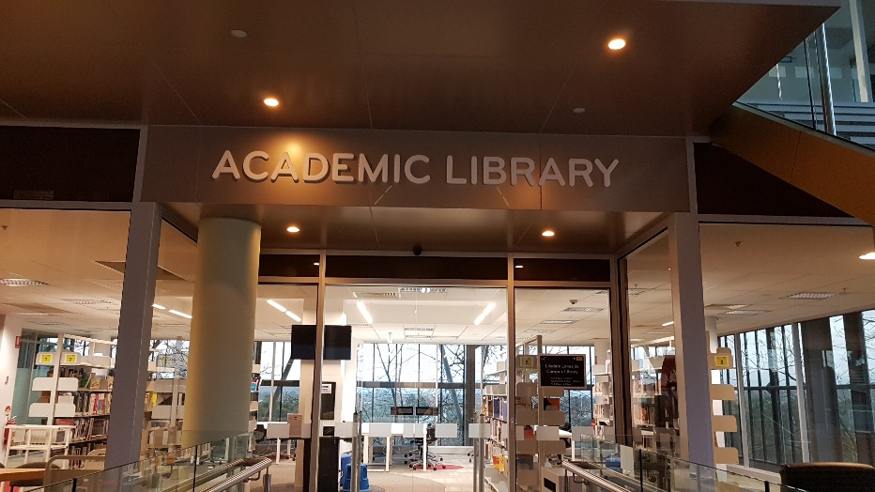

Chisholm Institute

We bid Colin Sutherland a fond farewell as he retired from library life to spend more time with his twin grandsons and work in the family dog sitting business. He will be missed by all his Chisholm colleagues as well as by the wider TAFE library community.

We welcomed two new staff to the team. Tim Suttie, of Kangan fame, and Riannon Berkeley from the public library sector.

Term two and things have ramped up with planning for our move into the new four storey building. The Library will close for the week of August the 19th to allow for the movement of the collection and Library staff. An opening party for staff and students will be held when the Library reopens in the new premises on the 26th. The Library is situated on the ground floor and we will be sharing the building with the Health sector teaching departments such as Nursing, Hair & Beauty and Early Childhood.

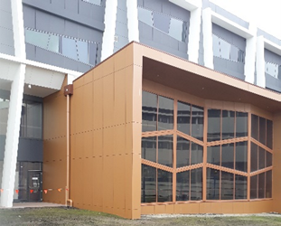
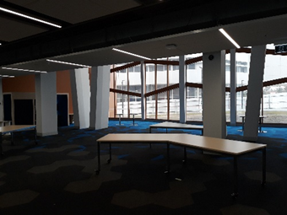

TAFE Gippsland [formerly Federation Training]

2018 was an exciting year for TAFE Gippsland with new Library acquisitions and capital works in the pipeline.

In February, the CEO Jonathon Davis resigned and Grant Radford, previously from Chisholm, was appointed as interim CEO. In August it was announced that Grant was to be appointed permanently to the position.

In June we went live with EBSCO Discovery Service. It has been a huge success and proved to be immensely popular with staff and students. We also signed up to Kanopy although the uptake of this has been quite slow in comparison.

In the Victorian state budget, it was announced that our Chadstone campus was to be sold to Holmesglen and the funds from the sale were going to fund a new campus in the township of Sale, which is scheduled to open in 2021. The existing campus in the area is located 10 kms from Sale and is old, expensive to maintain, hard to get to and no longer fit for purpose. Also flowing from the budget, the Morwell campus is being upgraded with the long term view of closing the nearby Yallourn campus; like Sale, Yallourn is old, expensive to maintain, a bit out of town and no longer fit for purpose.

In April the Gippsland Tech School at Morwell opened; this is a high-tech learning environment, with innovative education programs linked with local industry delivering real world learning to students. Students from eight participating schools in Gippsland are able to access the Tech School throughout the year for specialised programs.

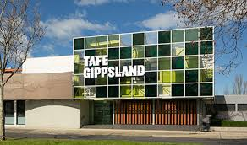

Federation University

A year in the life of FedUni! In March we welcomed Sue Owen as our new Director, Library and Learning Spaces. In May we celebrated IDAHOBIT Day and National Simultaneous Storytime across the campuses.

Wimmera hosted an online “live” reading of the book in the Library as well as an online “live” Auslan version, attended by Cert I students. This was the first time all students were able to enjoy the book at the same time.

Also at our Wimmera campus, we created a bookable group study space, tweaked the opening hours to open and close slightly earlier (and offered free hot chocolate to those students who were hardy enough to be out early in July!) and hosted a successful ANMAC (Nursing and Midwifery) accreditation visit. At our SMB campus we launched our after-hours space, which provides access to amenities as well as study facilities.

The Great Book Swap was run across the campus Libraries and the final amount raised was $613.75, with funds going towards improving indigenous literacy. In November we ran our biennial InSync Survey and performed extremely well, including meeting expectations for 9/10 of the factors of most importance to our TAFE students. We also started preparing for the Free TAFE programs by developing computer skills classes for 2019 intakes, to be offered at SMB, Mt Helen and Wimmera in 2019.

The Gordon

Goulburn Ovens Institute of TAFE (GOTAFE)

Holmesglen Institute

2018 was about Holmesglen launching and implementing a new Vision 2020 Strategic Plan.

Like most TAFE institutions while we did reasonably well in enrolments in the first half of the year in 2018, the challenges for the Institute in the second half of the year was to manage the impact of the Free TAFE campaign which negatively impacted the 2018 student enrolment numbers for all Victorian TAFEs.

At the end of 2018, all TAFE institutions were looking forward to the New Year and working towards a positive impact in student enrolment numbers in 2019.

The Holmesglen Vision 2020 goals related to the Library were:

- Create a Holmesglen Experience (HX) that supports the learner’s journey and our stakeholder interactions with Holmesglen

- The Library staff successfully embarked on a collaborative project with our Learning Skills Centre teachers to develop an online referencing tool to the APA 6th edition referencing style hosted on the Library web site, making it easier and more consistent for our students to use

- Holmesglen is investing in the capability and capacity of staff, i.e. to develop and implement a workforce capability plan that supports our Vision 2020 goals

We had Holmesglen’s first institute wide Professional Development Conference held at Caulfield Racecourse on 31 August 2018. The Institute was closed for the day and this conference was attended by all teaching and administration staff. Only essential services or service points were kept opened. In 2019 this conference will be held again at Caulfield on 30 August.

Build the ecosystem to connect with industry and the community

At the start of the year in 2018, Holmesglen added two new campuses, Drummond St campus - which was previously managed by Federation Training.

Drummond St will be the home of a new $16 million Victorian Tunnelling Training Centre, where Victorians will be trained in underground construction and tunnelling.

Bourke St campus – which is an acquisition of Navitas’ Health Skills Australia (HSA) at 206 Bourke St. This campus mainly offers the Diploma of Nursing.

Holmesglen also established a partnership with the St Kilda Football Club to provide education and training opportunities for Holmesglen students from the Bachelor of Sports Media program.

To expand our digital presence, create a distinctive Holmesglen Experience (HX) that is responsive to learners' preferences and industry requirements.

A new Online Community Portal was introduced to the Holmesglen community at the end of 2018 which was aimed at encouraging student’s peer to peer communication, i.e. to provide a space for students to interact and answer each other’s questions, including questions about the Library and Library services.

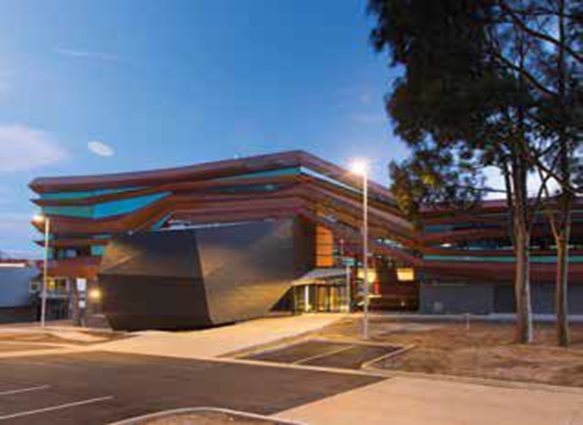
Drummond Street Campus

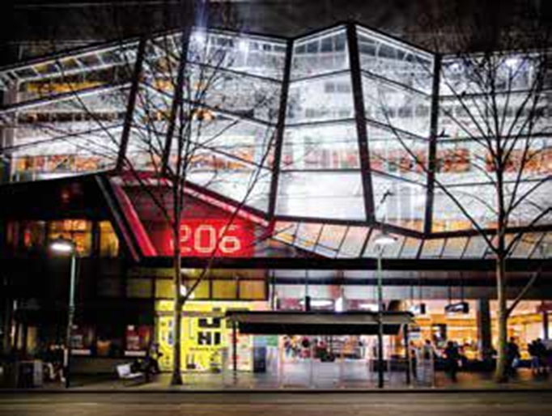
Bourke Street Campus

Melbourne Polytechnic

RMIT University
During 2018 RMIT University Library undertook a major envisioning project. After extensive consultation with our stakeholders, we defined the services we need to deliver to ensure our continued relevance in supporting the strategic direction of the University. We are now rolling out the delivery of those services and Library staff are embracing new ways of working.

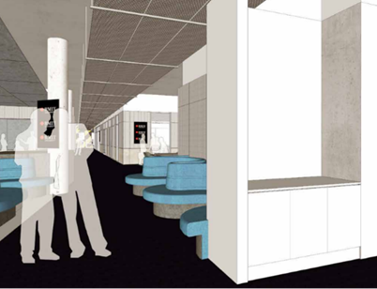

Building a new Library/VE Hub
One of the outcomes of the envisioning was around building our services to vocational education students. Our Carlton Library supports VE and we are pleased to be embarking on a major renovation project at that site. We'll create a vibrant new Library/VE Hub which will enhance the experience of our VE students. Here's a sneak peek of what's coming.

South West Institute of TAFE

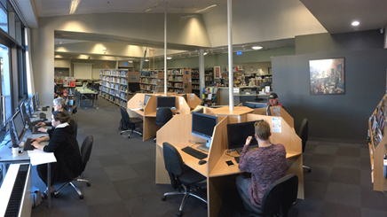
In 2018, the library launched its new look website which was developed through the Libguides platform. The new website incorporated detailed subject Libguides for courses provided at SWTAFE. This was well received for its ease of use.
Low staffing levels continued to be a challenge, and prevented us from visiting the unstaffed Library branches on a regular basis. The Library service point continued to operate jointly with the bookshop.
In the middle of 2018, SWTAFE underwent a CAL copyright audit of its online teaching resources and Library copyright staff were involved in assisting with this process.
Library staff were informed of plans to redevelop the Library to include an Innovation hub. This led to a major weed of the collection to allow for future relocation of the collection in a smaller space.
In October, future long term plans were also announced by the Labor government to invest $16.3 million to develop a learning hub for the community which would see the public library and the SWTAFE library combining into a new library space on the SWTAFE Warrnambool campus.

Sunraysia Institute of TAFE (SuniTAFE)

Swinburne University of Technology
Federation University

Level 2 of the Library refurbishment commenced towards the end of 2017 with a promise that it would be completed in time for Easter break 2018. As with most building projects both domestic and industrial there is often delays and SALS [Staff Administration and Library Services] rebuild was no exception. The new space was finished and open for business by mid-December 2018.

Student HQ were also moving into Library space at Croydon and Wantirna which meant that both campuses required some timely updates.

The new space on Level 2 at Hawthorn is a service hub for our students. The area is occupied by Library and Student HQ, Library Liaison officers, LAS, Medibank, International, IT TechBar, IT Rovers, Housing and Finance and Equipment [AV] borrowing.

The EAL collection, the Children Picture Book Collection and the Children’s Indigenous collection were relocated to Level 4. The Library’s hard copy collection, which includes journals are now on Levels 4 and 5. These levels are designated silent study areas.

SALS decided to trial a “Food for Fines” end of year initiative. Students with overdue Library fines were given the opportunity to donate food items to Uniting’s Food for Families end-of-year campaign helping to feed the homeless and unemployed families and children living in poverty. For each item donated $3.00 is deducted from the fine. The maximum amount of money that can be donated is $30.00. Lost items were not included for this initiative.

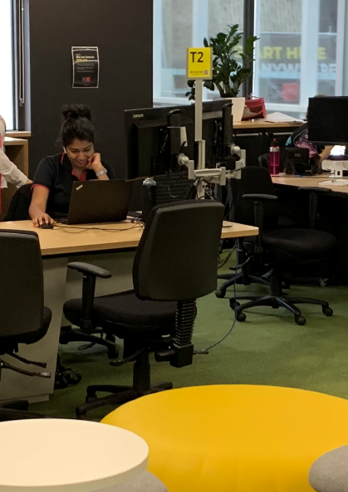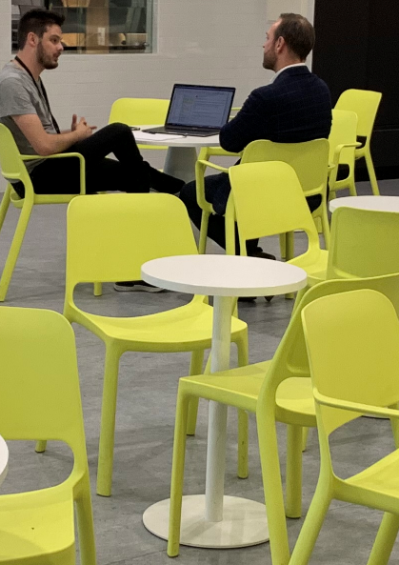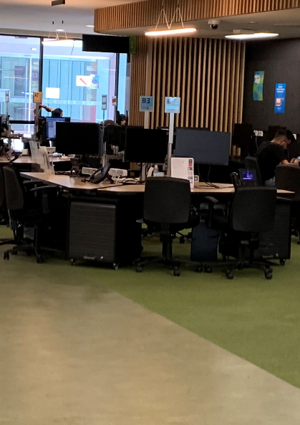

Victoria University
Federation University

William Angliss Institute
Federation University

Wodonga TAFE

Federation University

- Trial of LibAnswers chat and ticketing enquiry platform for TUTORspace and Library

- New database Anatomy.TV by Primal Pictures introduced mid-year. Teachers are able to access images and animations from the database for inclusion in learner resources and PowerPoint presentations. This eliminated the difficulty in finding good quality anatomy and physiology images with copyright permission. Students no longer need to purchase expensive anatomy and physiology textbooks

- The Library arranged for the Pop Up Library to visit Kids on Campus (KOC) childcare centre several times during the year. This has resulted in regular visits to the Library by KOC groups of children for story-time readings with KOC staff, and Library staff involved in story-time reading during events such as National Simultaneous Storytime, Book Week, Christmas and so on. KOC staff began regularly borrowing picture books for use at the childcare centre. The Pop Up Library visits also allowed us to promote community membership of the Library to community based families using the KOC childcare centre

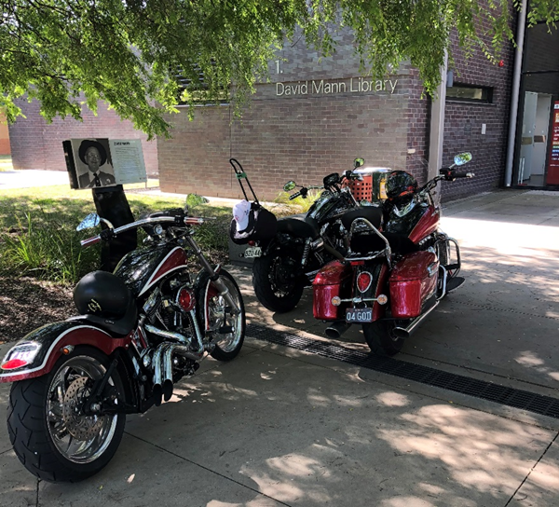

- The Library website and subject guides on LibGuides were reviewed and updated. This was prompted by a need to make maintenance and updating of the LibGuides more sustainable by the one Librarian after a part-time Librarian position was lost some years prior. Analysis of usage statistics showed that the most used resources from the subject guides were Library based resources (eBooks, Databases and so on) and that lists of relevant website links were rarely used. Subject guides were re-designed to be one page only and were embedded within the main Library homepage to consolidate all resources and usage within the one site as much as possible. Database widgets were reduced in number and objects re-used wherever possible. Galleries of new title book covers were improved on subject guides to promote resources and improve visual appeal. Some guides were merged, and a few new subjects added. The Research help guides were also revised and updated. The new guides were seamlessly rolled out to staff as the URLs remained unchanged so there was no need to update links in Moodle, although units with embedded subject guides did need updating. The new simplified English as an Additional Language guide immediately improved in usage after it was introduced to teaching staff. The updates went live in term 4 with editing continuing into 2019

- Work was completed to make all LibGuides content https compliant and the system was successfully updated to use https with the assistance of ICT. LibAnalytics was successfully migrated to the updated LibInsight platform. The Library continued to work closely with the Learner Services/Skills & Jobs HQ on use of LibInsight for collection of data, particularly for the Community Services Funding reporting

- Work was finally completed on a long running project to clean up serials catalogue records after some data was lost when transferred to the new library management system in 2015. All serials records were checked for accuracy which will make ongoing discovery and management of this collection much easier

- Library began work on a project involving academic integrity, plagiarism and referencing after teachers raised the issue of a plagiarism checking tool (such as Turnitin) at Education Committee.

